**INTERN PROJECT PHASE - 1**

**Data Analyst Projects: Exploring Data Insights**

**Project 1:** Iris Dataset Basic Analysis:

1. **Python code explanation:**

* First, I import the necessary packages for my Exploratory Data Analysis (EDA).
* Next, I identify which columns are not necessary in this dataset. I remove the 'Id' column because it is not used in the EDA. Then, I check the datatype of each column using the 'info()' method.
* After that, I want to know the null values in my dataset, so I use the 'isna().sum()' method. This function helps to determine the sum of null values in each column. Then, I drop the null values in my dataset.
* I use the 'describe()' method to obtain statistics such as count, mean, standard deviation, minimum, and maximum values for each column.
* Then, I use the 'corr()' method to compute the pairwise correlation of columns. I display the pairplot, histplot, and correlation plot to visualize the relationships between multiple variables, distribution, and the correlation between variables in the dataset.

1. **PowerBI explanation:**

* In Power BI, I first insert the slicer widget. When I click on a specific species in the slicer, it provides an interactive output for that species.
* Next, I insert five cards to display the sum of Sepal Length, Sepal Width, Petal Length, Petal Width, and the total count of null values in the dataset.
* Then, I use two pie charts to display the count of each Sepal Length, Sepal Width, Petal Length, Petal Width, and to visualize the distribution of species in the dataset.
* Additionally, I import a correlation heatmap to visualize the relationships between the variables and their correlation coefficients.

1. **PowerBI output screenshot:**

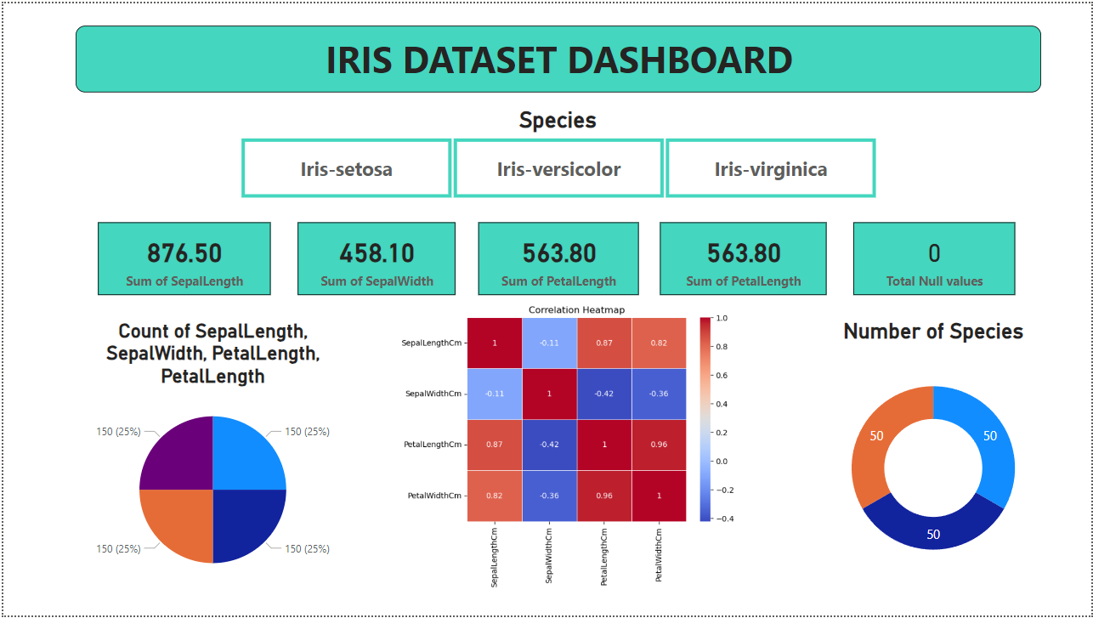

**Project 2:** Weather Analysis:

1. **Python code explanation:**

* In Weather Analysis, first, I preprocess the data to determine the datatype, null values, statistics values, etc.
* Then, I visualize the box plot to identify outliers in the category-related columns and to visualize the correlation.
* After that, I use Regression for weather predictions. In the weather predictions, I select some important columns as the predict_var, and I select the 'RainTomorrow' column as the target_var.
* Before the Regression, I encode the 'RainTomorrow' column using Label Encoder for model fitting, prediction, and printing the MSE, MAE, and R2 score to evaluate the performance of the Regression model.

1. **PowerBI explanation:**

* In PowerBI, I insert three slicers: Rain Today, Rain Tomorrow, and Wind Gust Direction to obtain interactive output in the table and all cards.
* Then, I insert the table widget. When I click on any slicer, it displays the specific slicer-related rows. Additionally, when I click on any row in the table, it displays the output in the five cards.
* After that, I use the five cards to obtain the output when I click on the slicer or table row. I display the interactive output for Wind Gust Direction, Rain Today, Rain Tomorrow, Wind Direction 9am, and Wind Direction 3pm in the five cards.
* These insights help to determine the timing of rainfall for today and tomorrow. Additionally, they enable advanced visualization techniques.

1. **PowerBI output screenshot:**

